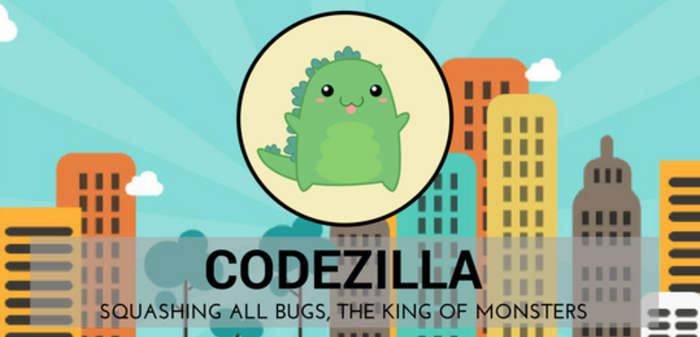

# CODEZILLA MEETING MINUTES

|  |  |  |  |  |  |  |  |  |
| --- | --- | --- | --- | --- | --- | --- | --- | --- |
| Details of Meeting | | | | | | | | |
| Meeting Title | | Iteration 3 – Internal Meeting 1 – Review of Account Modules I and II | | | | | | |
| Date (DD/MM/YYYY) | | 13/06/2017 | | | **Time** | | 07:00PM – 10:45PM | |
| Location | | SMU LKS Library Project Room 5-5 | | | | | | |
| Minutes Prepared By | | Edward Foo | | | **Minutes Vetted By** | | Amanda Lim | |
| Attendees | | Zul Yang  Koh Xiao Wei  Edward Foo  Nigel Goh  Amanda Lim  Jolene Teo | | | **Absentees** | | - | |
| Meeting Objective | | | | | | | | |
| To ensure that everyone is up to date with the sprints and Account Module I and II | | | | | | | | |
| Meeting Agenda | | | | | | | | |
| 1. Updates on Account Module I 2. Updates on Account Module II 3. Completion of outstanding tasks | | | | | | | | |
| Meeting Notes, Discussion | | | | | | | | |
| S/N | **Topic** | **Details** | | | | | | **To Note** |
| 1 | Updates on Account Module I  (Registration, Login) | -Brief recap and updates were given on Account Module I:   * Registration - * Password has to be hashed and stored in database * Boolean enabled required for account verification upon registration (true means verified) * Need to automatically create a verification token by hashing (token to be sent by email) * Verification token needs to be checked if expired (7 Days) * Other fields fall under amend profile * Login - * Plaintext able to verify the cipher text * Check if the account has been verified (enabled) * Every successful login changes the hash * Note login attempts (5 consecutive fails will lock account – enabled to false. Same method to unlock) | | | | | |  |
| 2 | Updates on Account Module II  (KMSI, Forget Password, Amend Profile) | Brief recap and updates were given on Account Module II:   * Keep Me Signed In (KMSI) - * Use of cookie * Forget Password * Same unlock logic, requires setting of new password and storing a new one * Save my password (Remember Me) – Redundant due to functions by Google Chrome | | | | | | *Removal of Remember Me due to redundancy? |
| 3 | Tasks | -Remaining time was used to complete our outstanding tasks:   * Wire frames * Front end and back end coding * Test cases for Sprint 3 * Project management for Jira | | | | | |  |
| Actionable Items | | | | | | | | |
| S/N | **To Be Done** | | | **Team Member(s)** | | | **Due Date (DD/MM/YYYY)** | |
| 1 | Testing completed already, test Plan and test case results for sprint 2 to be uploaded | | | Jolene | | | 16/06/2017 | |
| 2 | Project management space – Jira to be finalized | | | Zul | | | 16/06/2017 | |
| 3 | Wire frames | | | Amanda | | | 16/06/2017 | |
| Next Meeting (If Applicable/Discussed) | | | | | | | | |
| Date (DD/MM/YYYY) | | | 15/06/2017 | | | **Time** | 07:00PM – 10:30PM | |
| Location | | | SMU LKS Library Project Room 5-5 | | | **Objective** | TBC | |
|  | | | | | | | | |